DR. AMBEDKAR COLLEGE, DEEKSHABHOOMI, NAGPUR

DATE: 13.09.2023 , TIME: 9.00am to 10.30am.
NAME OF THE PROGRAM: Webinar on Prevention of Sexual Harassment at Higher Educational Institution: A Discourse
NAME OF THE SPEAKER: ADV. VIVEK AWCHAT
NAME OF THE PROGRAM CO-ORDINATOR: DR. MRS. SANDHYA KALAMDHAD
NUMBER OF ATTENDEES: 295 (GIRLS: 157 ; BOYS – 138)
NAME OF THE VENUE: ONLINE - ZOOM PLATFORM

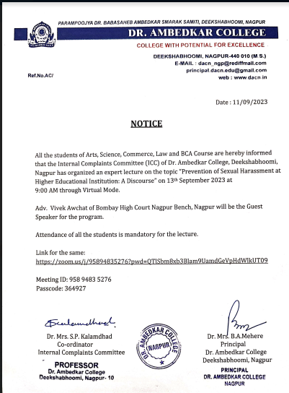

The Internal Complaints Committee (ICC) of Dr. Ambedkar College, Deekshabhoomi, Nagpur organized a webinar on “PREVENTION OF SEXUAL HARASSMENT AT HIGHER EDUCATIONAL INSTITUTION: A DISCOURSE” ON 13TH September 2013 for the students of Arts, Commerce, Science, and Law Faculty. Near about 295 attendees were present in the programme.

The resource person of the workshop Was Adv. Vivek Awchat, Practicing Lawyer at The Bombay High Court Nagpur Bench, Nagpur.

The program commenced with the welcome address by Prof. Dr. Mrs.B.A.Mehere, Principal, Dr. Ambedkar College Deeksha Bhoomi Nagpur.

The growth of a society is often determined by the way it treats its most vulnerable sections; women and children are among the most vulnerable in a society like ours and to safeguard their rights is of paramount importance. Sexual harassment of women in general and such harassment at workplaces is a phenomenon that puts women at higher levels of risk. A robust mechanism against the same goes a long way in safeguarding their interests. And therefore Adv. Awchat started his session with the briefing about the landmark decision of the Supreme Court in Vishakha v. State of Rajasthan as it laid down elaborate guidelines to deal with the menace of sexual harassment against women at workplaces.

He explained all the relevant provisions of Sexual Harassment at Workplace (Prevention, Prohibition and Redressal) Act, 2013. He also explained how related international conventions like the Convention on the Elimination of Discrimination against Women (CEDAW) were referred to fill the gap in our Indian legislature with regard to sexual harassment at workplaces.

He further explained the meaning of sexual harassment, its possible effects on the victims, procedure for filing the complaint as per the provisions the Act, duty of the employer to frame rules regarding the same, constitution of internal complaints committee etc.

He also covered provisions with regard to the mechanism and role of the Internal Complaints Committee and Local Committee under the Act, the interim relief available to the victim, quantum of punishment and duties of the employer.

He also carefully explained the provision under the Indian Penal Code against sexual harassment like outraging the modesty, assault or criminal force to woman with intent to outrage her modesty, Voyeurism, He also gave few examples of few words and songs intended to insult the modesty of woman covered under Section 509 of IPC.

The session culminated with Adv.Awchat taking questions and by showing his concern that not much has been done for and how engaging man in prevention of sexual harassment can be dealt with.

The programme was compared by Ms. Anusha Patre , Assistant Professor from the Department of Law, Dr. Ambedkar College, Deekshabhoomi, Nagpur under the guidance of Dr. Mrs. Sandhya Kalamdhad, Professor and Co-ordinator of the Internal Complaints Committee Dr. Ambedkar College Deeksha Bhoomi Nagpur.

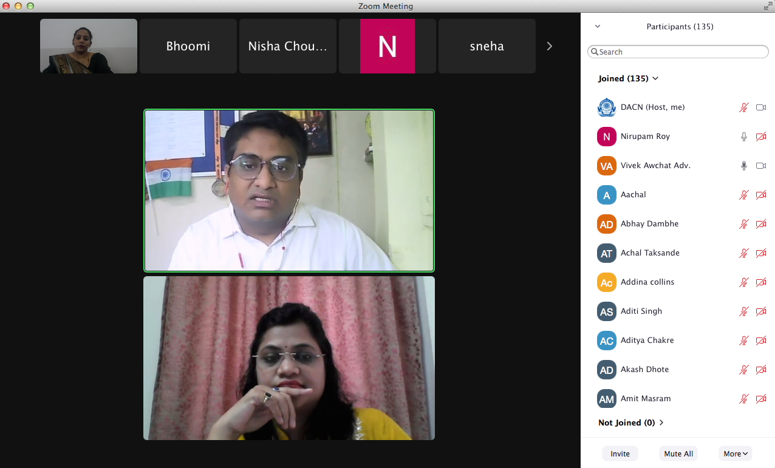

Adv.Vivek Awchat during his session

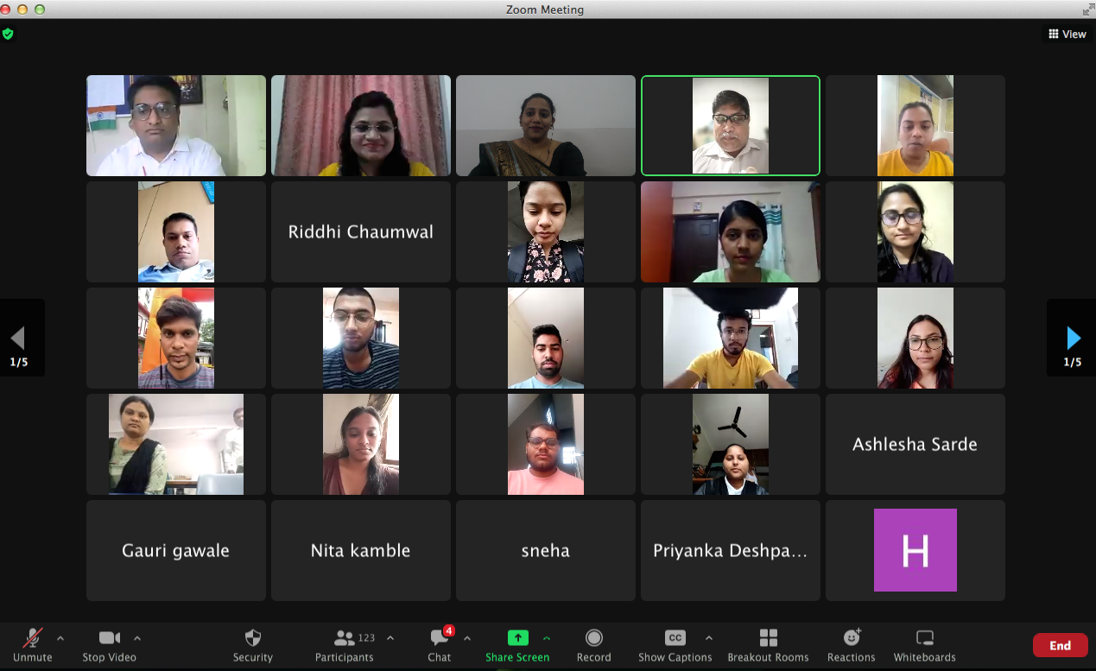

Participants in the session

